What is EPA’s Strategic Plan?
Strategic Planning
Annual Planning and Budgeting
Implementation
Accountability for Results

Draft FY 2022-2026 EPA Strategic Plan – Fact Sheet
- Communicates EPA’s vision, priorities, and strategies to accomplish the agency’s mission over the next four years
- Serves as the framework for annual planning and budgeting and development of grant work plans
- Provides the basis for monitoring progress and adjusting strategies
- Meets government-wide requirements (Government Performance Results Act (GPRA) Modernization Act amended by Evidence Act)

What’s new in EPA’s draft Strategic Plan framework?
- Four principles: Follow the Science, Follow the Law, Be Transparent, Advance Justice and Equity
- New climate and environmental justice strategic goals and emphasis to embed in all EPA work
- Four cross-agency strategies emphasizing essential ways to work to achieve the strategic goals and objectives

Why your input matters?
- Helps us understand what is important to you and ways that we can better protect human health and the environment for all communities
- Helps us establish and maintain more effective partnerships

What input are we seeking?
- Advice and opinions based on your experiences to advance EPA’s mission
  - Most important outcomes
  - Most important opportunities for working together
  - Biggest barriers to success

What are the upcoming milestones?
- September 13, 2021: EPA submission of Draft FY 2022-2026 EPA Strategic Plan to OMB
- October/November 2021: Public review and comment; Tribal Consultation; Congressional Consultation – Draft FY 2022-2026 EPA Strategic Plan
- February 2022: Issuance of FY 2022-2026 EPA Strategic Plan

Draft FY 2022-2026 EPA Strategic Plan Framework
Mission: To Protect Human Health and the Environment
Principles: Follow the Science, Follow the Law, Be Transparent, Advance Justice and Equity
Strategy 1:
Ensure Scientific Integrity and Science-Based Decision Making
Strategy 2:
Consider the Health of Children and Other Vulnerable Populations in Our Work
Strategy 3:
Advance EPA’s Organizational Excellence and Workforce Equity
Strategy 4:
Strengthen Tribal, State, and Local Partnerships and Enhance Engagement
Goal 1:
Tackle the Climate Crisis
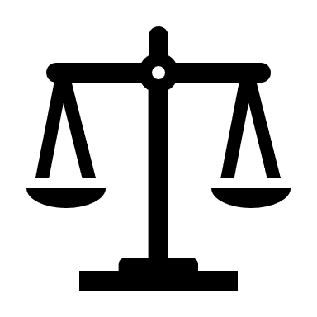
Goal 2:
Take Decisive Action to Advance Environmental Justice and Civil Rights
Goal 3:
Enforce Environmental Laws and Ensure Compliance
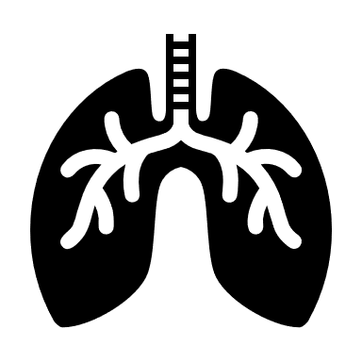
Goal 4:
Ensure Clean and Healthy Air for All Communities
Goal 5:
Ensure Clean and Safe Water for All Communities
Goal 6:
Safeguard and Revitalize Communities
Goal 7:
Ensure Safety of Chemicals for People and the Environment
- Obj 1.1: Reduce Emissions that Cause Climate Change
- Obj 1.2: Accelerate Resilience and Adaptation to Climate Change Impacts
- Obj 1.3: Advance International and Subnational Climate Efforts

- Obj 2.1: Promote Environmental Justice Efforts at the Federal, Tribal, State, and Local Levels
- Obj 2.2: Embed Environmental Justice into EPA’s Programs, Policies, and Activities
- Obj 2.3: Strengthen Civil Rights Enforcement in Communities with Environmental Justice Concerns

- Obj 3.1: Hold Environmental Violators and Responsible Parties Accountable
- Obj 3.2: Detect Violations and Promote Compliance

- Obj 4.1: Improve Air Quality and Reduce Localized Pollution and Health Impacts
- Obj 4.2: Reduce Exposure to Radiation and Improve Indoor Air

- Obj 5.1: Ensure Safe Drinking Water and Reliable Water Infrastructure
- Obj 5.2: Protect and Restore Waterbodies and Watersheds

- Obj 6.1: Clean Up and Restore Land for Productive Uses and Healthy Communities
- Obj 6.2: Reduce Waste and Prevent Environmental Contamination
- Obj 6.3: Prepare for and Respond to Environmental Emergencies

- Obj 7.1: Ensure Chemical and Pesticide Safety
- Obj 7.2: Promote Pollution Prevention

