**NPDES eRule Readiness and Reporting Dashboard (Version 2 – Beta Release) -**

**Request for Comments**

<https://echo.epa.gov/trends/npdes-erule-readiness-reporting-dashboard>

(ECHO Gov login required)

**Overview**

* The 2015 NPDES Electronic Reporting Rule (“NPDES eRule”) requires the EPA to assess the progress each authorized state is making in implementing NPDES electronic reporting and to repeat these assessments annually [see 40 CFR 127.26(j)]. These assessments are performed at the end of each June.
* EPA is using the ECHO NPDES eRule Readiness and Reporting Dashboard to conduct these assessments. Since November 2016, EPA has worked collaboratively with states to improve the functionality of the dashboard and the quality of the data supporting the dashboard.
* Currently the NPDES eRule Readiness and Data Completeness Dashboard (Version 1), which is currently on ECHO, shows the performance of facility, permit, and DMR data sharing efforts by EPA Regions and authorized NPDES programs. In particular, the dashboard tracks data completeness in EPA’s national NPDES data system (ICIS-NPDES) for facility, limits, and DMR data.
* Since the initial publication of the dashboard on ECHO in November 2017, EPA noted that it would update the dashboard to also show the reporting method, that is, display information on how the DMR data were received by the state (e.g., electronic, paper under an approved waiver, paper, etc.).
* EPA and most states are now collecting and sharing the data necessary to identify the DMR reporting method through use of the “Electronic Submission Type” field in ICIS-NPDES.
* Version 2 (beta) of the dashboard identifies how well states are doing at implementation Phase 1 of the NPDES eRule (DMRs) and how well they are doing at sharing these data with EPA’s ICIS-NPDES:
  + The DMR reporting method data are presented on the “DMR Reporting Method” tab.
  + The DMR data completeness data are presented on the “DMR Data Completeness” tab. These are the data currently shown on Version 1 of the dashboard.
* The user guide for Version 2 (beta) is available at: https://echo.epa.gov/help/npdes-erule-dashboard/npdes-erule-dashboard-reporting-help

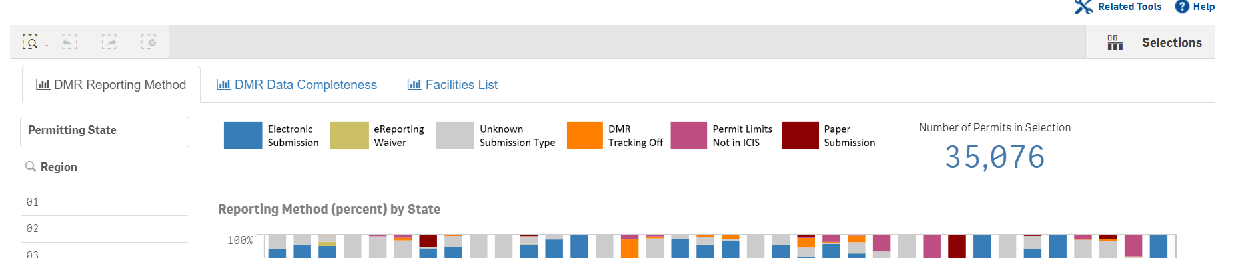

**Request for Comment**

We are seeking comments and suggestions from EPA Regions and states on Version 2 (beta). Please send any comments, suggestions, or requests for dashboard demonstrations to Carey Johnston ([johnston.carey@epa.gov](mailto:johnston.carey@epa.gov)). It would be helpful to receive your comments by July 17, 2020. Please feel free to share with your colleagues as needed.

EPA will revise the dashboard displays to reflect the comments received and will then allow states time to make adjustments to their data sharing practices as needed before releasing Version 2 of the dashboard to the public.  EPA plans to make the dashboard available to the public sometime in the first half of 2021, and also plans to use the data from the “DMR Reporting Method” tab for the June 2021 annual assessment [see 40 CFR 127.26(j)].  Thank you for all your efforts in implementing NPDES electronic reporting.

**Quick Access Guide for Version 2 (Beta)**

1. Please log into ECHO Gov. You can set up an “ECHO Gov” user account if you don’t already have one.

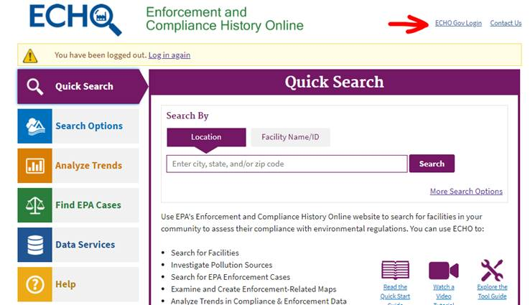

1. You should then see your username. Then click on “Analyze Trends” and then “Data Visualization Gallery.” Select the “NPDES eRule Readiness and Reporting Dashboard” from the list of options on the gallery. You can also access the dashboard via the following URL (after ECHO Gov login): https://echo.epa.gov/trends/npdes-erule-readiness-reporting-dashboard

